*DataCamp Chapter*

Q1: Decision trees work with divide-and-conquer strategy, as mentioned on DataCamp chapter, session Making decisions with trees on 1:50. If dataset contain two data points which have same feature values but different target values, can we say that there are missing features on the model?

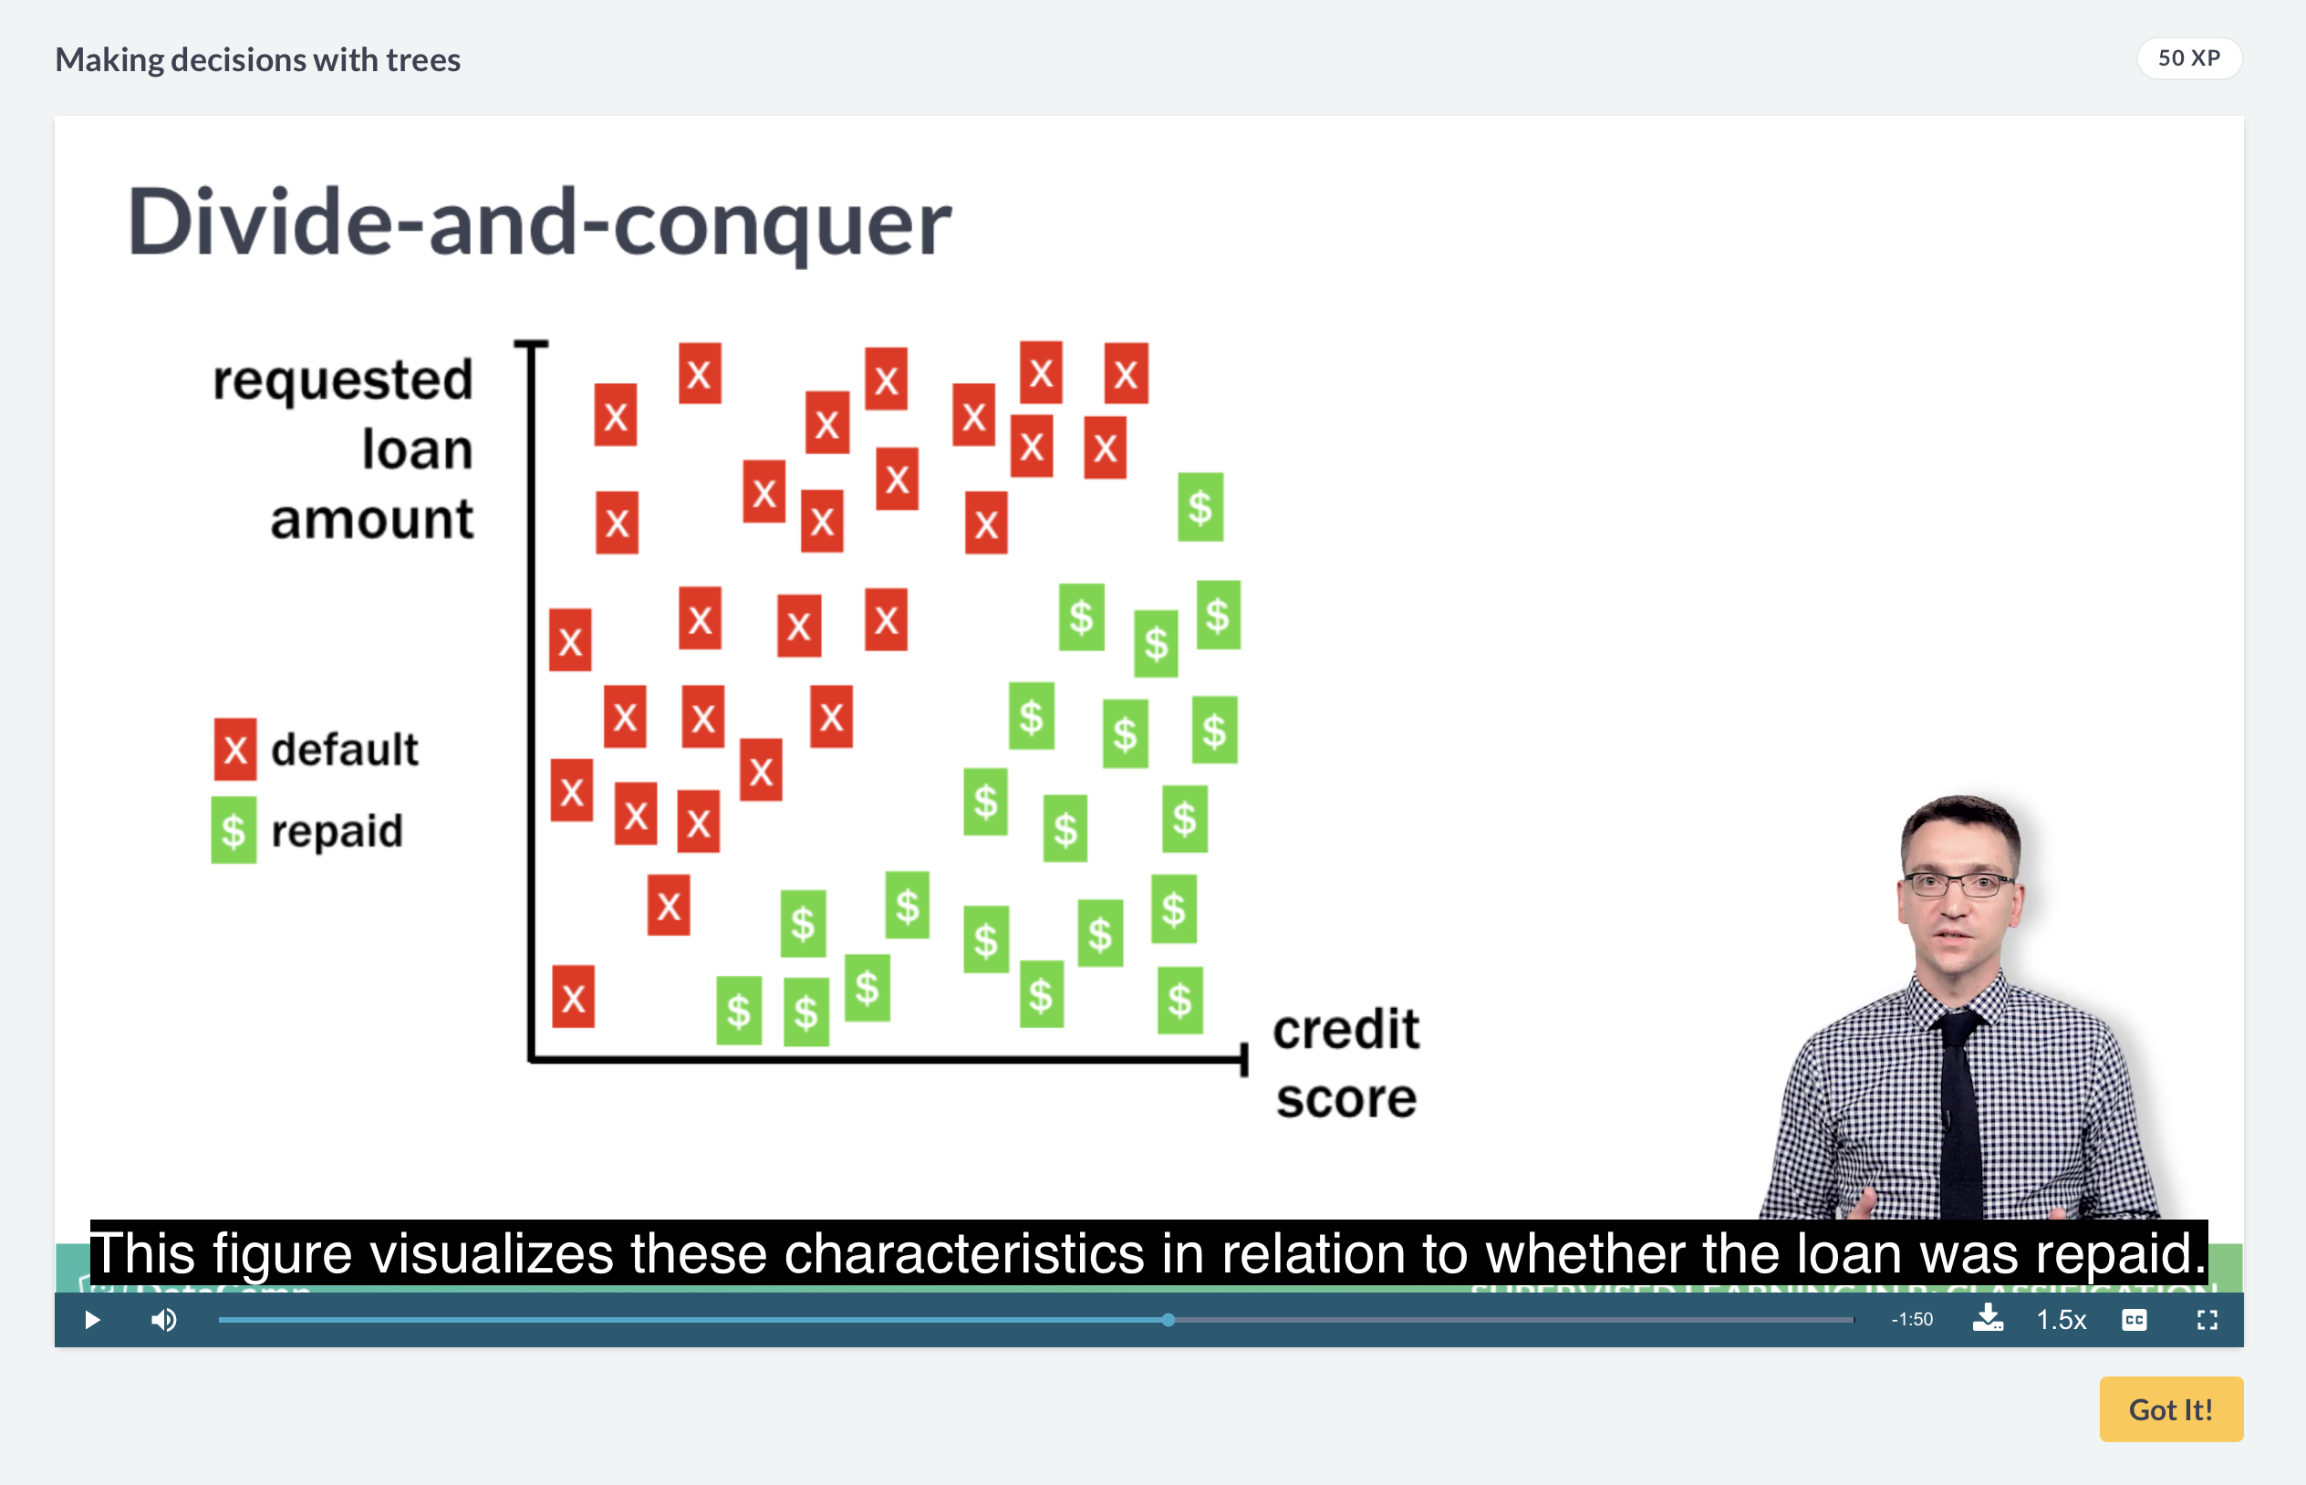

*Titanic: Getting Started With R - Part 3: Decision Trees*

Q2:

We know that decision trees are tend to overfit on dataset from learning materials of current week. In real world problems, how decision trees help us to understand data? Where can we use it?

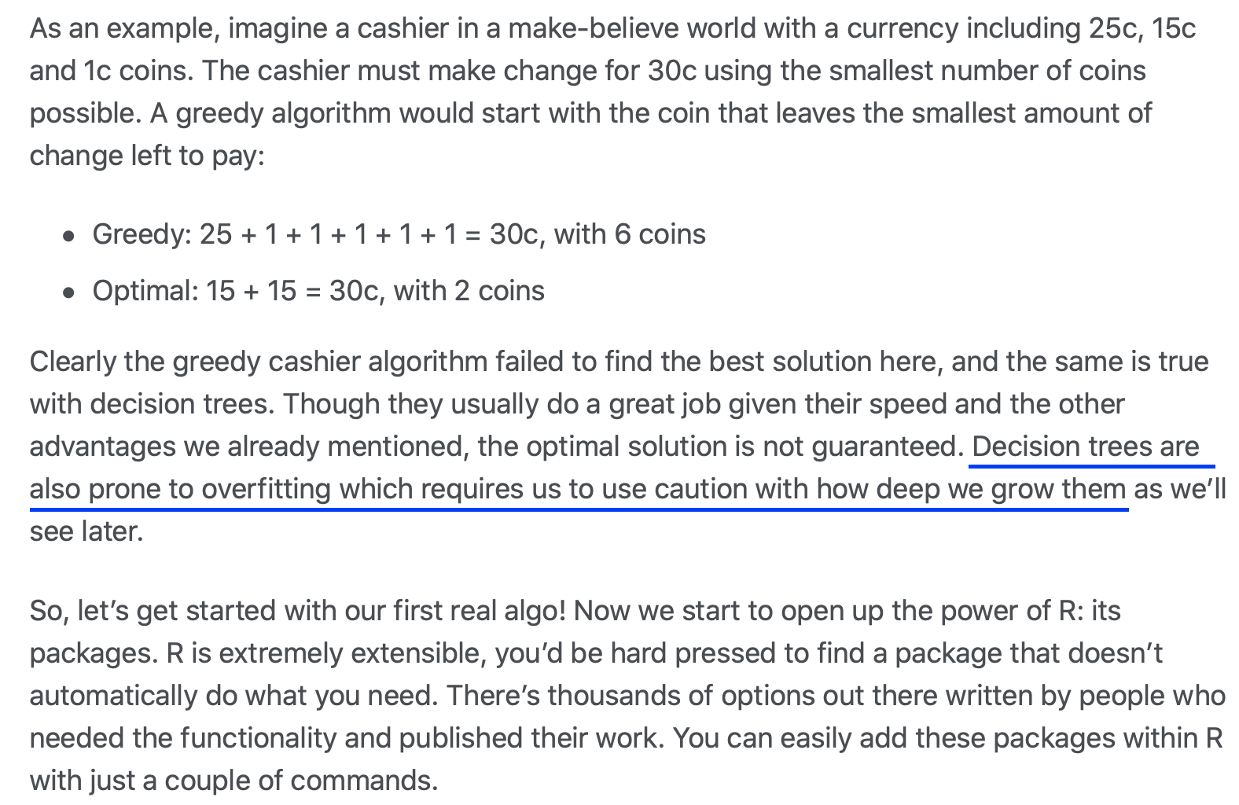

*A visual introduction to machine learning*

Q3: As mentioned on the visual explanation of decision trees with the example of house prices, because the model learn all of data point, the accuracy of the model reached 100%. Which accuracy of decision trees is generally enough? What should we interrupt the tree?